The Limits of Optical Crop Monitoring: Quantifying Monsoon Observation Gaps in Sylhet Rice Systems
1. Abstract
This study quantifies observation gaps during the monsoon-dominated Aman monitoring period in Sentinel-2 imagery for Transplanted Aman (T. Aman) rice systems in Sylhet, Bangladesh. Across three consecutive Aman cycles (2022–2024), 126 acquisition opportunities were analyzed using a Google Earth Engine (GEE) processing pipeline incorporating s2cloudless and cloud-shadow detection. At a primary validity threshold of 50% clear cropland, overall observation availability was limited to 37.30% (47 valid observations). Temporal analysis revealed a maximum within-season gap of 55 days, occurring between June 5 and July 30, 2023. Sensitivity analysis demonstrated that while the maximum gap remained stable between the 50% and 80% thresholds, it increased to 90 days at a 90% threshold, representing a substantial portion of the monitoring window. These data voids indicate that cloud and shadow contamination substantially compromise temporal continuity during the early and peak monsoon. The results underscore the methodological necessity for agricultural monitoring systems to distinguish direct empirical observations from interpolated estimates when reconstructing vegetation trajectories in cloud-prone environments.
2. Introduction
Sentinel-2 imagery and the Normalized Difference Vegetation Index (NDVI) are foundational tools for modern agricultural monitoring, enabling the tracking of crop phenology and health^{[1]}. However, the efficacy of these tools is constrained by atmospheric conditions. The key issue is therefore not simply whether Sentinel-2 acquires imagery frequently, but how frequently those acquisitions contain sufficient clear cropland to support a defensible observation.
In Bangladesh, persistent cloud cover during the monsoon season necessitates rigorous cloud masking. Cloud-prone conditions across South Asian rice landscapes are well documented, and have historically pushed operational rice-mapping efforts toward radar-based alternatives precisely because optical revisit does not translate into usable observation frequency^{[2]}. While masking ensures data quality by removing contaminated pixels, it creates temporal “data voids” in the NDVI time series. These voids are frequently filled by interpolation or smoothing techniques to create continuous datasets. This research quantifies the extent of these gaps in Sylhet, asking: How does monsoon-period cloud and shadow contamination affect the temporal availability and reliability of Sentinel-2 observations for NDVI-based rice monitoring in Sylhet?
Although Sentinel-2 provides frequent nominal observations, nominal revisit frequency does not necessarily represent usable agricultural observations. In cloud-prone environments, the distinction between image acquisition and spatially sufficient clear-surface observation is particularly important. This study therefore evaluates observation availability using a cropland-aware criterion rather than relying solely on scene-level cloud metadata.
3. Methodology
3.1 Study Area and Period
The study focuses on a 15.10 km² non-haor T. Aman rice plain located in Dakshin Surma/Sylhet Sadar. Haor regions were excluded to avoid confounding cloud-induced gaps with seasonal submergence. The monitoring window is defined as June 1 to December 31 for the years 2022, 2023, and 2024. The June–December window was selected to encompass the expected Aman production period in the study area. The study does not independently verify field-level phenological stages within the ROI.
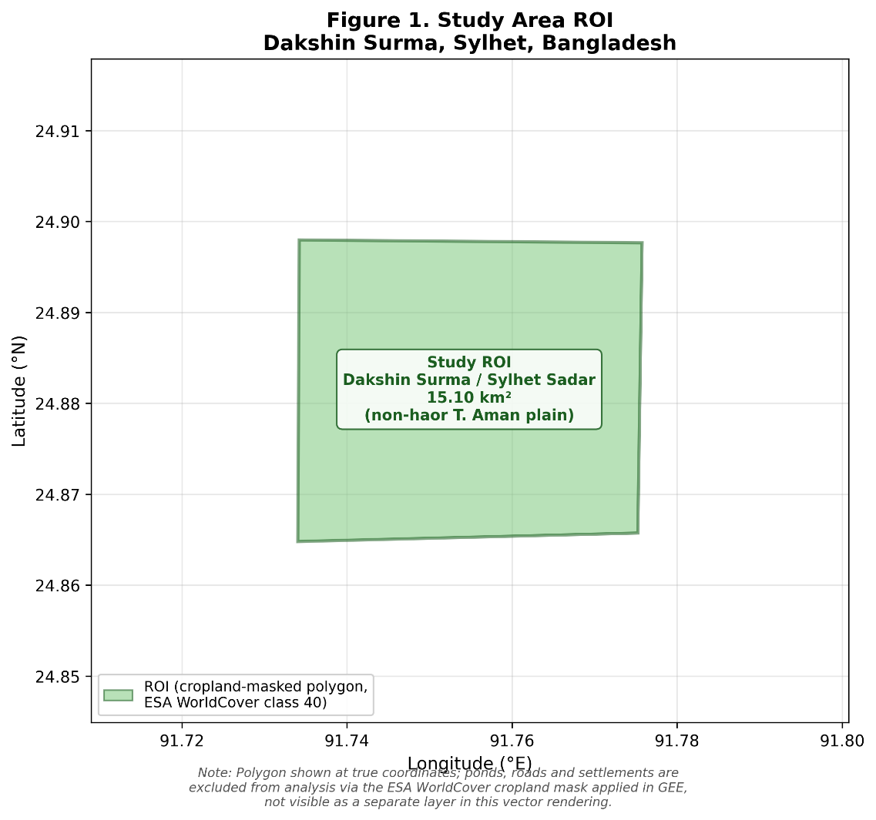
Figure 1: Study Area ROI Dakshin Surma, Sylhet, Bangladesh
3.2 Data Acquisition
Data was sourced from the Sentinel-2 Level-2A Surface Reflectance (Harmonized) collection. This period (2022–2024) ensures consistent dual-satellite coverage from Sentinel-2A and 2B/2C, together providing a nominal 5-day revisit frequency at the equator, and better than 5 days at Sylhet's mid-latitude owing to orbital swath overlap^{[1]}.
This nominal revisit rate describes acquisition frequency, not usable-observation frequency. Global assessments of Sentinel-2 metadata show that higher acquisition frequency does not reliably translate into more cloud-free scenes, since cloudiness is spatially and seasonally structured rather than randomly distributed^{[5]}. In a monsoon-dominated setting such as Sylhet, this distinction is the central motivation for the present study: even where the sensor constellation revisits the ROI every five days, a run of consecutive acquisitions can still fail to clear the clear-cropland threshold, producing the multi-week observation gaps quantified in Section 4. The gap analysis in this study is therefore best read as a measure of usable observation frequency under monsoon cloud conditions, not of sensor revisit performance.
3.3 Data Processing Pipeline
The workflow utilized GEE to join Sentinel-2 SR data with the s2cloudless cloud probability dataset^{[3]}. Cloud shadows were detected by projecting cloud masks based on solar azimuth and identifying dark pixels in the Near-Infrared (NIR) band. A morphological buffer was applied to expand contaminated regions and suppress small features.
The key processing parameters were as follows: cloud probability threshold = 40%; Near-Infrared (NIR) dark-pixel threshold = 0.15; cropland extent defined using ESA WorldCover class 40 (Cropland)^{[4]}; and clear-cropland percentage calculated at 10 m spatial resolution aligned to the Sentinel-2 B4 (Red) band projection.
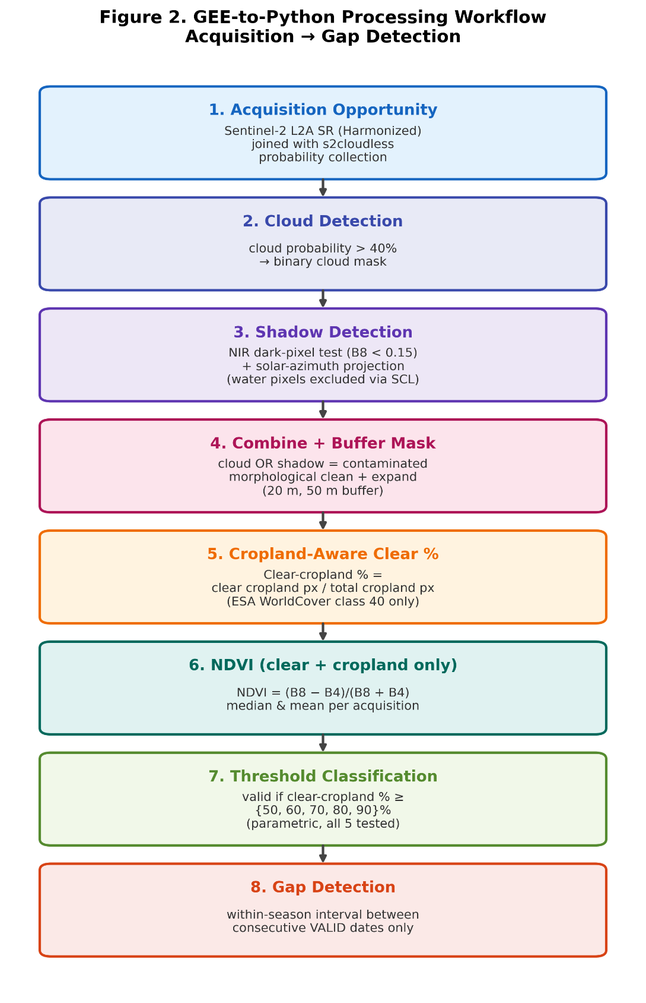
Figure 2: GEE to Python Processing Workflow
3.4 Technical Definitions
- Acquisition opportunity: A Sentinel-2 image available for the ROI.
- Valid observation: An acquisition where clear-cropland % ≥ selected threshold.
- Invalid acquisition: An acquisition where clear-cropland % < selected threshold.
- Temporal observation gap: The interval between two consecutive valid observation dates within the same Aman season.
- Raw NDVI availability: The NDVI median is null when clear-cropland % = 0% (no clear, non-cloud, non-shadow cropland pixels were available within the ROI for that acquisition, so no value could be computed).
- Threshold-based observation invalidity: The acquisition contains an NDVI estimate but does not satisfy the selected clear-cropland validity criterion.
Acquisition availability was calculated at the image/acquisition level, whereas temporal gaps were calculated using unique calendar dates after removing same-date duplicate acquisitions (e.g., concurrent Sentinel-2A and Sentinel-2C overpasses).
3.5 Mathematical Framework
The analysis utilized the following metrics for quantifying spatial and temporal availability:
Clear-cropland % = (Clear cropland pixels ÷ Total cropland pixels) × 100
Gapᵢ = Dateᵢ₊₁ − Dateᵢ
(where both Dateᵢ and Dateᵢ₊₁ are consecutive valid observation dates within the same season).
3.6 Sensitivity Analysis
The study evaluated the impact of different quality requirements by testing five clear-cropland validity thresholds: 50%, 60%, 70%, 80%, and 90%.
4. Results
4.1 General Availability
A total of 126 acquisition opportunities were identified across the three-year study period. At the primary 50% clear-cropland threshold, only 47 observations were classified as valid, resulting in an overall availability of 37.30%.
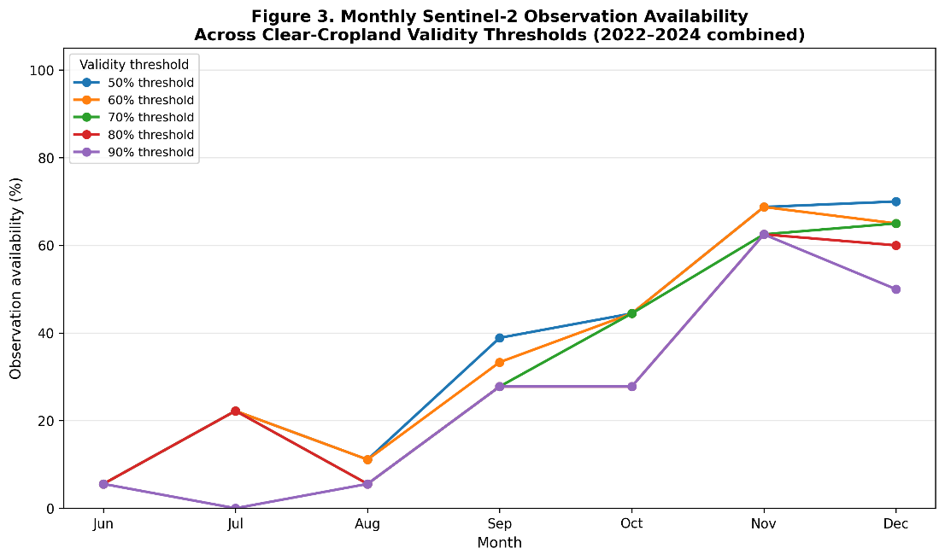
Figure 3: Monthly Observation Availability Across Clear-Cropland Validity Thresholds (2022–2024) — Temporal Pattern of Availability During the Aman Season
4.2 Temporal Gap Analysis
The analysis identified significant periods of missing data. The longest temporal gap was 55 days, occurring between June 5 and July 30, 2023. This interval occurs during the early portion of the defined Aman monitoring window, when fine-scale temporal interpretation may be particularly difficult due to the lack of direct optical evidence. This 55-day figure is a pooled maximum across the three study seasons; Section 6 notes the corresponding limitation of not yet decomposing it by individual year.
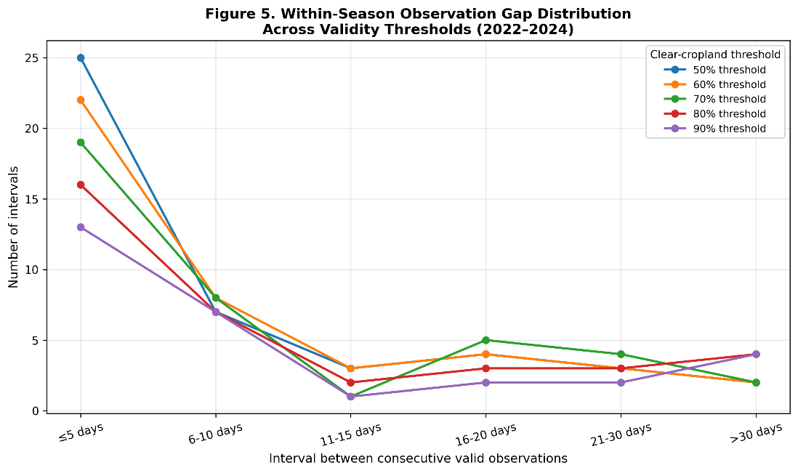
Figure 4: Within-Season Observation Gap Distribution Across Validity Thresholds (2022-2024)
4.3 Threshold Sensitivity and Maximum-Gap Expansion
Sensitivity analysis showed that the maximum within-season gap remained 55 days from the 50% through 80% thresholds, but increased to 90 days at the 90% threshold. Increasing the threshold from 80% to 90% removes observations that previously maintained temporal continuity, causing multiple shorter intervals to merge into a substantially longer gap. This 90-day interval represents a substantial portion of the defined Aman monitoring window.
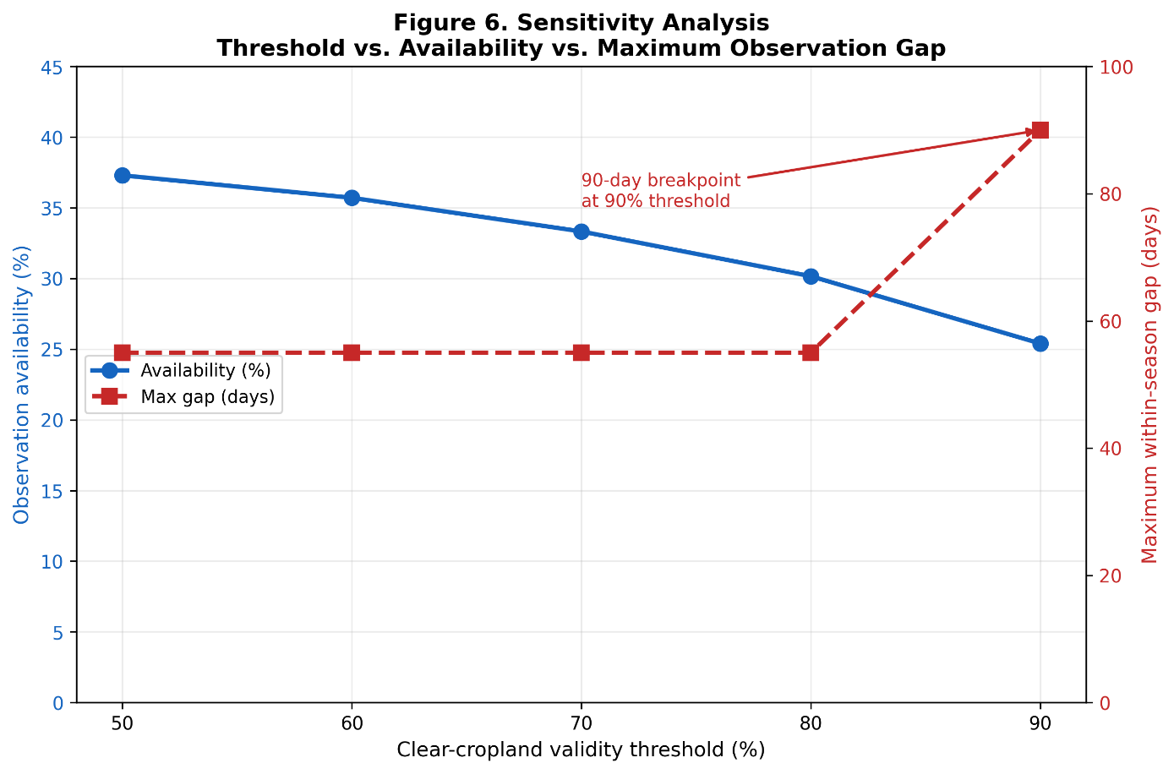
Figure 5: Threshold Sensitivity — Availability and Maximum Observation Gap as a Function of the Clear-Cropland Validity Threshold
4.4 Missing Data Consistency
It is important to distinguish between raw NDVI availability and threshold-based validity, since these represent different stages of the processing pipeline. NDVI median values are null precisely when clear-cropland % = 0%, meaning no clear, non-cloud, non-shadow cropland pixels were available within the ROI for the reducer to compute a value; this occurred for 58 of the 126 acquisitions. The remaining 68 acquisitions had a computable NDVI median. Applying the primary 50% clear-cropland validity threshold classified 47 of these 68 acquisitions as valid observations; the other 21 acquisitions had a nonzero but insufficient clear-cropland percentage (0% < clear-cropland % < 50%) and were therefore classified as invalid despite having a computed NDVI value. Combined with the 58 acquisitions with a null NDVI median, this yields a total of 79 invalid acquisitions (58 + 21) under the 50% threshold, consistent with the overall availability of 37.30% (47 of 126). Table 1 summarizes this reconciliation.
Table 1. Reconciliation of NDVI Availability and Threshold-Based Validity (n = 126)
Category | Number
Total acquisitions | 126
NDVI median available (clear-cropland % > 0%) | 68
NDVI median null (clear-cropland % = 0%) | 58
Valid observations (clear-cropland % ≥ 50%) | 47
Invalid acquisitions (clear-cropland % < 50%) | 79

4.5 Directly Observed NDVI Time Series
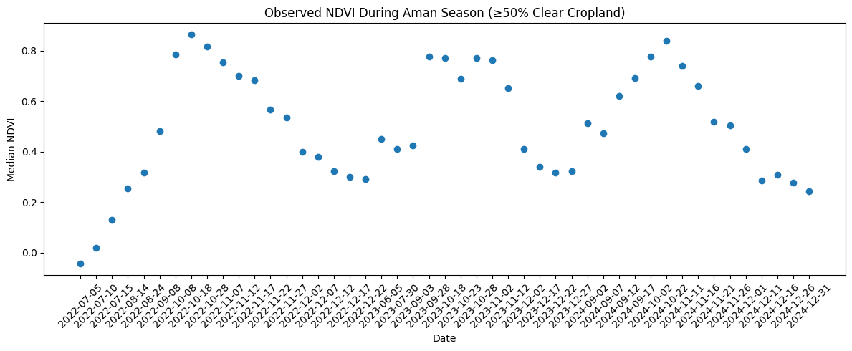
Figure 6. Directly observed NDVI values from acquisitions satisfying the 50% clear-cropland validity criterion. Points represent direct observations; no interpolation was applied between observations.
5. Discussion
5.1 The Clustering Effect
Overall availability summarizes how many acquisition opportunities were usable, but it does not describe how those observations are distributed through time. The 55-day interval demonstrates that relatively sparse usable observations can be clustered in ways that create substantial periods without direct optical evidence.
5.2 Implications for Interpolation
The identified gaps create periods in which continuous NDVI reconstruction would require interpolation or other estimation methods rather than direct observations. If these gaps were filled through interpolation or smoothing, the resulting reconstructed trajectory would contain intervals determined by estimation rather than direct optical observations, particularly across the 55- and 90-day gaps identified in this study.
5.3 Availability in Context: How Cloud-Prone Is Sylhet?
Read on its own, a 37.3% observation availability could reflect either an unusually cloud-prone site or a general feature of monsoon-season optical remote sensing in South and Southeast Asia. The broader literature points to the latter. Global metadata assessments of the Sentinel-2 archive show that cloud contamination is spatially and seasonally structured, and that acquisition frequency alone is a poor predictor of usable-scene frequency^{[5]}. Tropics-wide analyses combining Landsat and Sentinel-2 time series similarly report multi-week to multi-month waiting periods between cloud-free observations in persistently cloudy regions, even where nominal revisit is frequent^{[6]}. Against this backdrop, the 37.3% availability and 55–90-day gaps found for Sylhet are consistent with, rather than exceptional relative to, monsoon-affected optical remote sensing generally — they quantify a known regional constraint rather than revealing a site-specific anomaly.
This context also explains why operational rice mapping in South Asia's cloud-prone lowlands has historically favored Synthetic Aperture Radar (SAR) over optical data: prior work mapping paddy rice across cloud-prone Bangladesh and Northeast India used Sentinel-1 SAR precisely because optical revisit could not be relied upon to deliver clear-sky observations during the growing season^{[2]}. The present study's optical-only availability figures are therefore best read as a quantitative case for that established practice, rather than as a critique specific to the Sylhet ROI: they show, in numeric terms, the size of the gap that a SAR-based or optical–SAR fusion approach would need to close for this study area.
5.4 Answer to the Research Question
Taken together, these results answer the study's research question: monsoon-period cloud and shadow contamination substantially reduces the temporal availability of Sentinel-2 observations for NDVI-based rice monitoring in Sylhet, and does so in a manner consistent with documented patterns elsewhere in the monsoon tropics^{[5,6]}. The more actionable finding, however, is not the availability percentage in isolation but its temporal distribution: low overall availability manifested as a small number of severe, clustered gaps (55–90 days) rather than as a uniform thinning of the record. For downstream users, this distinction matters more than the headline percentage — a time series with occasional 90-day voids demands a fundamentally different interpolation or fusion strategy than one with the same overall availability spread evenly across the season. The primary limitation this study identifies is therefore not reduced image availability as such, but the uneven temporal distribution of the observations that remain usable.
6. Scientific Weaknesses & Limitations
- Detected “gaps” are artifacts of the selected masking procedure and thresholds, not proof of zero usable information from the sensor.
- Biological interpretation is constrained by a lack of independent ground-truth farming calendars for the specific ROI.
- Cloud masking parameters involve inherent trade-offs between commission and omission errors.
- Results are seasonally and ROI-specific; they quantify contamination during the Aman window and may not represent annual monsoon behavior outside this agricultural context.
- The study is restricted to optical data and does not incorporate Synthetic Aperture Radar (SAR) alternatives, which are less affected by cloud cover.
- The reported 55- and 90-day maximum gaps are pooled statistics across the three study seasons (2022–2024). A year-by-year decomposition of the maximum gap has not yet been computed for this draft, so it is not possible to state from the current results alone whether 2023 is representative of typical monsoon behavior or is driving the pooled maximum as an anomalous year. This decomposition is a recommended addition prior to submission.
7. Evidence Table
Key Monitoring Metrics for Sylhet Aman Seasons (2022-2024)
Threshold (%) | Valid Observations (n) | Availability (%) | Maximum Gap (Days) | Primary Gap Period | Change in Availability vs. 50% (pp)
50% | 47 | 37.30 | 55 | June 5 – July 30, 2023 | Baseline
60% | 45 | 35.71 | 55 | June 5 – July 30, 2023 | -1.59 pp
70% | 42 | 33.33 | 55 | June 5 – July 30, 2023 | -3.97 pp
80% | 38 | 30.16 | 55 | June 5 – July 30, 2023 | -7.14 pp
90% | 32 | 25.40 | 90 | June 5 – September 3, 2023 | -11.90 pp

8. Conclusion
Within the selected Sylhet agricultural ROI, cloud- and shadow-screening substantially reduced the availability of Sentinel-2 acquisitions that met the study's clear-cropland quality criterion. At the 50% clear-cropland criterion, only 37.3% of acquisition opportunities were considered valid, and the longest within-season interval between valid observations reached 55 days. Stricter validity criteria further reduced observation continuity. These findings are consistent with independent assessments of Sentinel-2 data availability in cloud-prone and tropical settings more broadly^{[5,6]}, reinforcing that they reflect a regional and seasonal constraint on optical monitoring rather than a peculiarity of the study site. The findings support an uncertainty-aware approach to NDVI time-series analysis in cloud-prone agricultural environments, in which direct observations and temporally estimated values are explicitly distinguished.
9. References
[1] Drusch, M., Del Bello, U., Carlier, S., Colin, O., Fernandez, V., Gascon, F., Hoersch, B., Isola, C., Laberinti, P., Martimort, P., Meygret, A., Spoto, F., Sy, O., Marchese, F., & Bargellini, P. (2012). Sentinel-2: ESA's optical high-resolution mission for GMES operational services. Remote Sensing of Environment, 120, 25–36. https://doi.org/10.1016/j.rse.2011.11.026
[2] Singha, M., Dong, J., Zhang, G., & Xiao, X. (2019). High resolution paddy rice maps in cloud-prone Bangladesh and Northeast India using Sentinel-1 data. Scientific Data, 6, 26. https://doi.org/10.1038/s41597-019-0036-3
[3] Braaten, J., Schwehr, K., & Ilyushchenko, S. (2020). More accurate and flexible cloud masking for Sentinel-2 images. Google Earth Engine (Medium). https://medium.com/google-earth/more-accurate-and-flexible-cloud-masking-for-sentinel-2-images-766897a9ba5f
[4] Zanaga, D., Van De Kerchove, R., Daems, D., De Keersmaecker, W., Brockmann, C., Kirches, G., Wevers, J., Cartus, O., Santoro, M., Fritz, S., Lesiv, M., Herold, M., Tsendbazar, N.-E., Xu, P., Ramoino, F., & Arino, O. (2022). ESA WorldCover 10 m 2021 v200 [Data set]. Zenodo. https://doi.org/10.5281/zenodo.7254221
[5] Sudmanns, M., Tiede, D., Augustin, H., & Lang, S. (2020). Assessing global Sentinel-2 coverage dynamics and data availability for operational Earth observation (EO) applications using the EO-Compass. International Journal of Digital Earth, 13(7), 768–784. https://doi.org/10.1080/17538947.2019.1572799
[6] Flores-Anderson, A. I., Cardille, J., Azad, K., Cherrington, E., Zhang, Y., & Wilson, S. (2023). Spatial and temporal availability of cloud-free optical observations in the tropics to monitor deforestation. Scientific Data, 10, 550. https://doi.org/10.1038/s41597-023-02439-x

